SCHOOLOFCOMPUTER SCIENCE AND ARTIFICIAL INTELLIGENCE |  |  |  |  | DEPARTMENTOFCOMPUTER SCIENCE ENGINEERING
ProgramName:M.Tech/MCA/MSC |  |  |  | AssignmentType: Lab |  |  | AcademicYear:2025-2026
CourseCoordinatorName |  |  |  | Venkataramana Veeramsetty
CourseCode |  |  |  | CourseTitle |  | AI Assisted Problem Solving Using Python
Year/Sem |  |  | I/I | Regulation |  | R25
DateandDay  of Assignment |  |  |  | Time(s)
Duration |  |  | 2 Hours | Applicableto  Batches
AssignmentNumber:16.3(Presentassignmentnumber)/24(Totalnumberofassignments)
 | Q.No. | Question |  |  |  |  |  | ExpectedTime  to complete
 | 1 | Lab 16 – Database Design and Queries: Schema Design and SQL Generation  Lab Objectives  - To practice basic SQL query generation with AI assistance.  - To analyze AI-suggested queries for correctness and efficiency.  - To understand how AI can help in documenting and improving database logic.  Learning Outcomes  After completing this lab, students will be able to:  - Use AI tools to design a simple ER diagram / schema for a given scenario.  - Generate CREATE TABLE statements using AI.  - Write and refine basic SQL queries (SELECT, INSERT, UPDATE, DELETE).  - Validate correctness and efficiency of AI-generated SQL.  - Compare AI-generated vs manually written queries.  Task Description #1 – Schema Generation  Task: Ask AI to design a schema for a Library Management System (Tables: Books, Members, Loans).  SQL Code  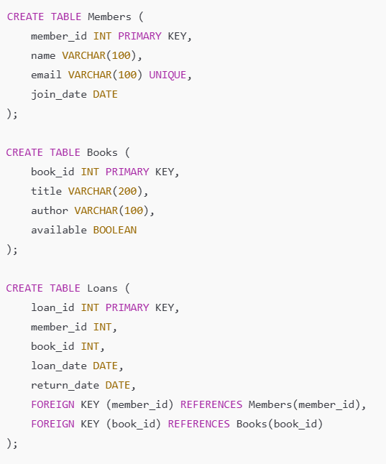  Prompt:  "Create an in-memory SQLite database using Python.  Define and execute SQL commands to create three tables:  - Books (BookID, Title, Author, ISBN, PublicationYear, Status)  - Members (MemberID, Name, Address, PhoneNumber, Email)  - Loans (LoanID, BookID, MemberID, LoanDate, ReturnDate)  Include primary keys and foreign key constraints.  After creating them, display each table’s schema using PRAGMA table_info()."  Code Generated:  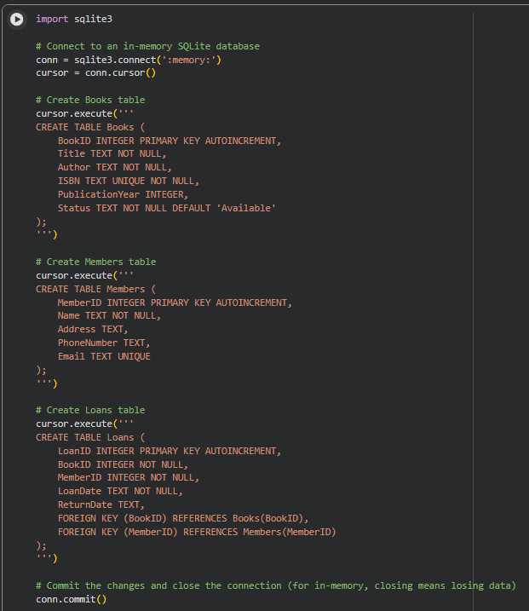  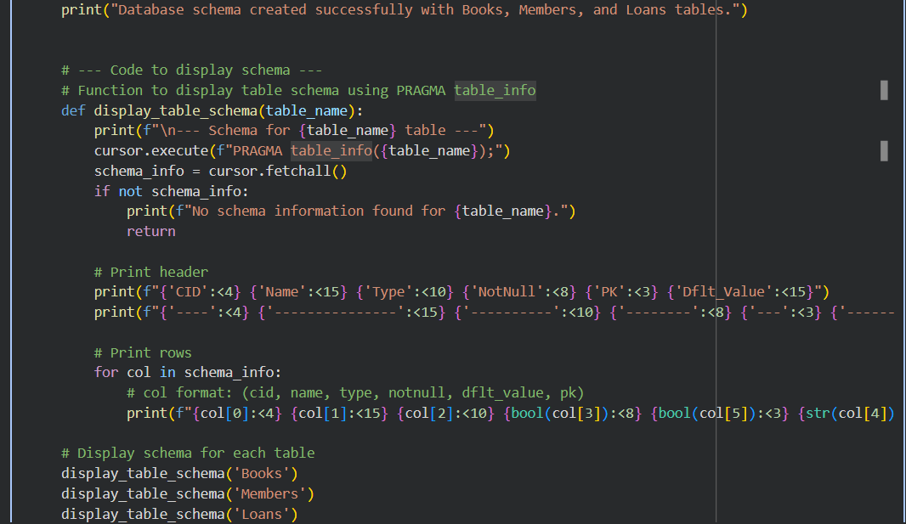  Output:  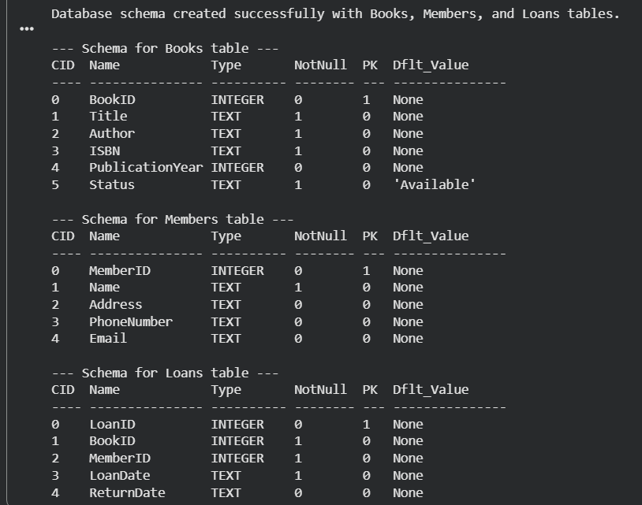  Task Description #2 – Error Insert Data  Task: Ask AI to generate INSERT INTO queries for the schema above (3 sample records per table).  Prompt:  Insert sample data into the in-memory SQLite database:  – Add 3 example Books  – Add 3 example Members  – Add 3 example Loans linked by valid BookID and MemberID.  After inserting, query each table and display the inserted rows."  Code Generated:  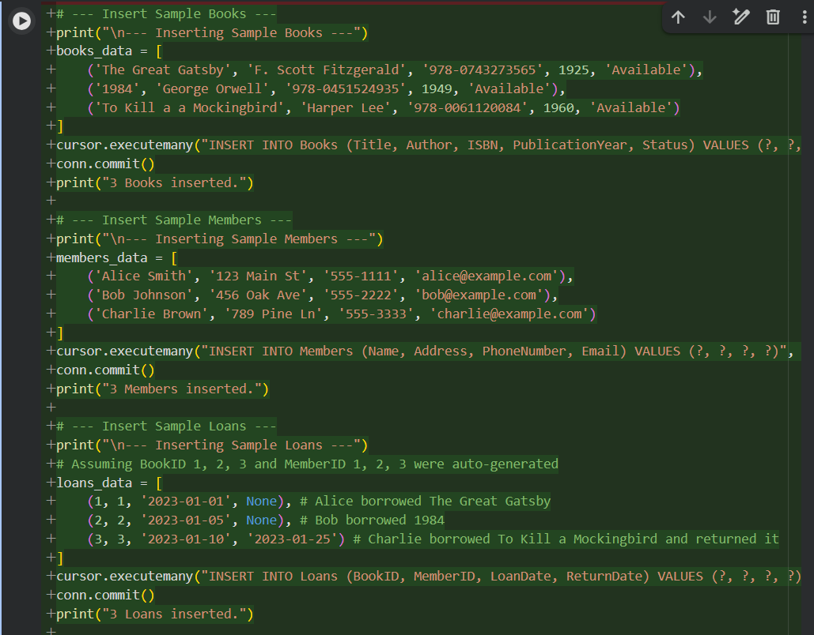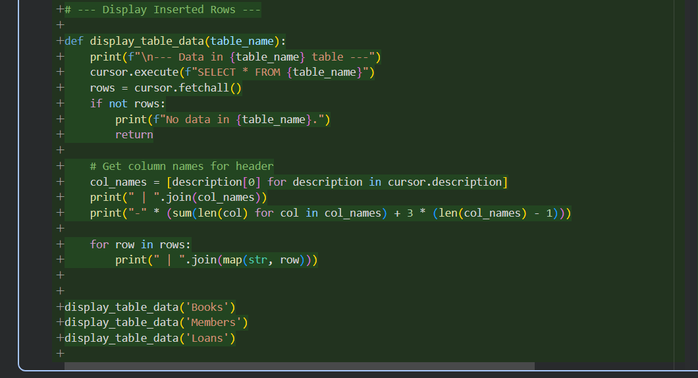  Output:  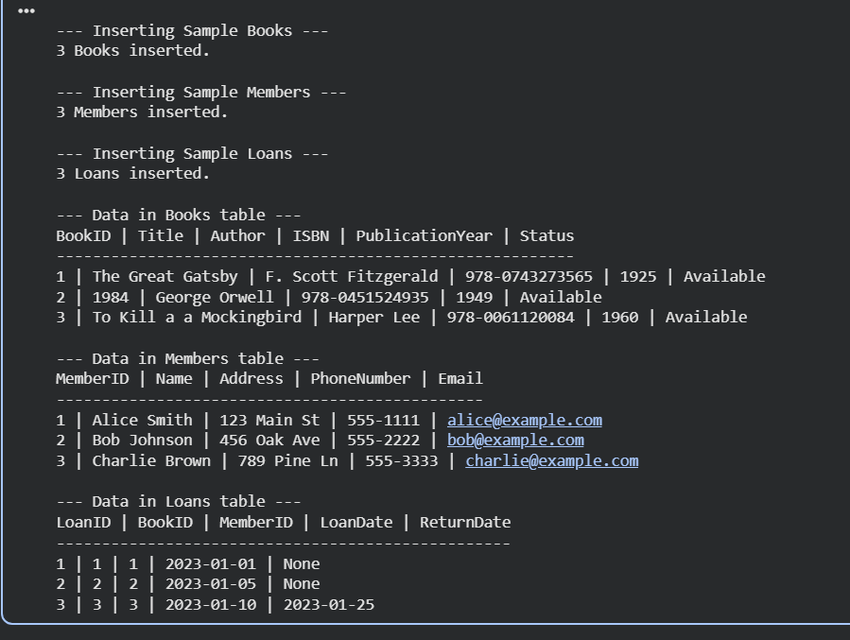  Task Description #3 – Basic Queries  Task: Use AI to generate a query to list all books borrowed by a specific member  Prompt:  "Write Python code that queries the Loans table joined with Books and Members to show:  Book title, Member name, Loan date, and Return date.  Display the results in a readable table format."  Code Generaeted:  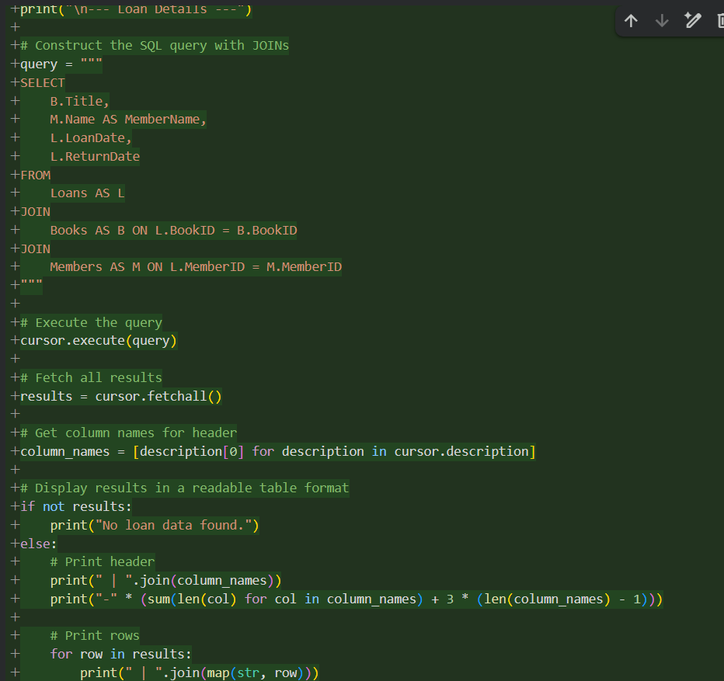  Code Output:  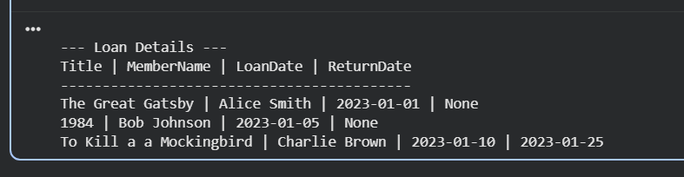  Task Description #4 – Update and Delete Queries  Task: Generate queries with AI for:  - Updating a book’s availability to FALSE when borrowed.  - Deleting a member record safely.  Prompt:  *"Write SQL/Python code to:  - Update a book’s Status to FALSE when it is borrowed (based on a Loans entry).  - Safely delete a Member record while maintaining referential integrity.  After both operations, display the updated Books and Members tables."*  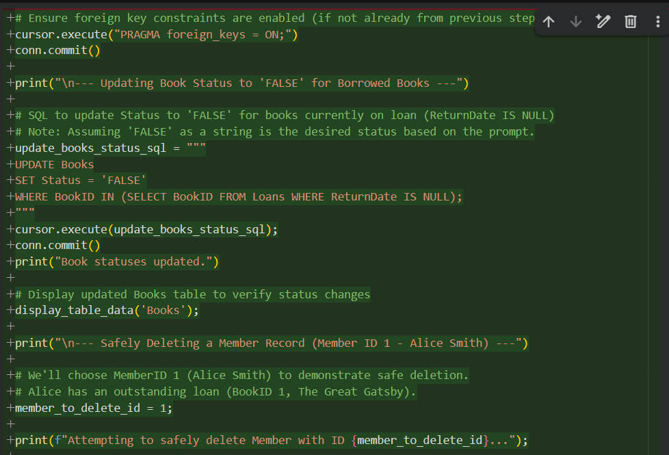  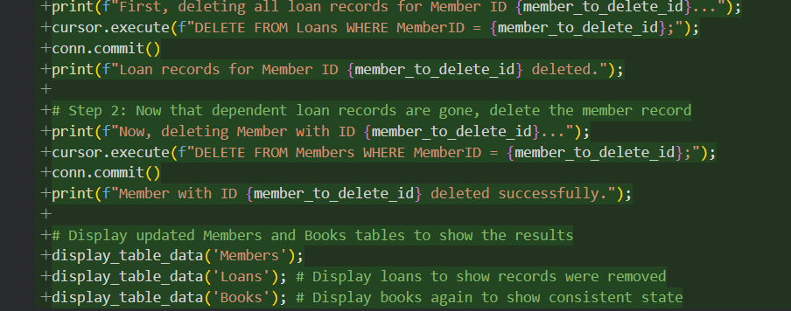  Code Output:  